# Exploring age-specific and cumulative cohort rates using composite fertility lattice plots: an international comparison of Human Fertility Database and Human Fertility Collection data

Serena Pattaro, School of Social and Political Sciences, University of Glasgow

E-mail: [Serena.Pattaro@glasgow.ac.uk](mailto:Serena.Pattaro@glasgow.ac.uk)

Laura Vanderbloem, School of Public Health, Imperial College London

E-mail: [l.vanderbloemen@imperial.ac.uk](mailto:l.vanderbloemen@imperial.ac.uk)

Jon Minton, School of Social and Political Sciences, University of Glasgow

E-mail: [Jonathan.Minton@glasgow.ac.uk](mailto:Jonathan.Minton@glasgow.ac.uk)

# Abstract

## BACKGROUND

The Human Fertility Database (HFD), and the related Human Fertility Collection (HFC), provide highly disaggregated data on age-specific fertility rates for 45 countries. These sources provide a wealth of opportunity for learning about the development of different pathways of transition to low fertility both within and between countries and geographic regions.

## OBJECTIVE

The aim of this paper is to use composite fertility lattice plots, which combine information from different visualisation methods of the Lexis surface, such as heat maps and shaded contour plots, to explore changes in age-specific fertility rates and derived cumulative cohort fertility rates across countries and geographic regions.

## METHODS

Standard shaded contour maps use both shade and contour to represent the same variable. In our plots we instead use colour/shade to indicate age-specific fertility rates, and a series of distinct contour lines to indicate the cumulative fertility rates reached by different cohorts at different ages. These figures are then ranked by cumulative cohort fertility rates in the last commonly observed period, and colour coded according to geographic region.

## RESULTS

By looking first at the thick solid contour lines from left to right in each population figure, we can see at which age different cohorts either reached or last reached replacement fertility levels. Other contours help understand the degree of shortfall below replacement levels for different cohorts. It appears that, once countries have fallen below a replacement fertility level, they tend to not return to it. Exceptions are Norway and the USA, which saw rising fertility rates for cohorts born after 1950s and late 1960s, respectively. The age-specific fertility trends, as well as broader political and socioeconomic conditions in these countries, are very different, suggesting different paths by which replacement fertility rates can be achieved.

## CONTRIBUTION

Complex data visualisations show, in an intuitive way, how age-specific fertility rates are related to cumulative cohort fertility rates. Combining this information enables us to explore differences between countries and geographic regions and can make an important contribution to comparative demographic research on fertility and other trends.

Key words:

Fertility; Lexis Surfaces; Data Visualisation; Human Fertility Database

# Introduction

One of the key drivers underpinning population change is the continuing transition to low fertility (Billari and Kohler, 2004; Lutz and Skirbekk, 2005). The fertility transition, as a process of fertility decline from high to below replacement levels, is one of the cornerstones of the demographic transition, both in its classic proposition (Davis, 1945; Notestein, 1945, 1953) and in the proposition of the ‘second demographic transition’ (Lesthaeghe and van de Kaa, 1986; Lesthaeghe, 1995, 2010). The transition to low fertility interrelates with improvements in life expectancy (Oeppen and Vaupel, 2002; Shkolnikov *et al.*, 2011; Sánchez-Barricarte, 2017) and international migration patterns (Andersson, 2004; Kulu, 2005; Sobotka, 2008; Dubuc, 2012; Adserà and Ferrer, 2014).

Since the late 1960s, most countries from the Western world have undergone a rapid fertility decline, which have been accompanied by an increasing postponement of childbearing to older ages, but there are also important variations between countries. Within the European context, there is an emerging debate about the persistence of low fertility, with some studies reporting recuperation in cohort fertility trends (see Caltabiano, Castiglioni, and Rosina (2009) for Italy; Andersson et al. (2009) for Nordic countries and Sobotka et al. (2011) for German-speaking countries and the United States) and others revealing a reversal in period fertility trends among European countries (Goldstein, Sobotka and Jasilioniene, 2009; Myrskylä, Goldstein and Cheng, 2013). Yet the transition to low and later fertility has become a characteristic feature which is not solely restricted to the European and, more generally, Western regions, but encompasses an increasing number of non-Western countries, notably those in East and South-Asian region (Frejka, Jones and Sardon, 2010; Basten, Sobotka and Zeman, 2014; Frejka, 2017).

The transition to low fertility has been shaped by a complex and dynamic combination of technological, institutional, socio-economic, political, cultural and normative factors. The driving forces behind the transition to low fertility include the diffusion of modern contraception (Bongaarts and Watkins, 1996; Montgomery and Casterline, 1996; Kohler, 2001), educational expansion (Blossfeld and Huinink, 1991; Skirbekk, 2008; Lutz, Butz and KC, 2014), the large-scale entry of women into the labour force (Sundström and Stafford, 1992; Oppenheimer, 1994; Adserà, 2011), family policies (d’Addio and d’Ercole, 2005; Thévenon, 2011; Rindfuss and Choe, 2015), globalisation and economic uncertainty (Mills and Blossfeld, 2005), ideational changes (Lesthaeghe and Surkyn, 1988), gender roles and gender equality (McDonald, 2002, 2006; Anderson and Kohler, 2015; Esping‐Andersen and Billari, 2015; Goldscheider, Bernhardt and Lappegård, 2015; Frejka, 2017).

The aim of this paper is to provide a description and an illustration of different fertility trends across 45 countries and regions from major geographic clusters or macro-regions within and outside Europe (for full details see the online appendix). The latter reflect different institutional, societal, economic and cultural conditions which have shaped different pathways of low fertility transition. Changes in age-specific and cumulative cohort fertility rates are explored by using composite fertility lattice plots, which combine information derived from different visualisation methods of the Lexis surface, namely heat maps and shaded contour plots (see also Schöley and Willekens (2017)).

In particular, we present and describe the processes involved in producing a lattice plot which shows both age-specific fertility rates (ASFRs) available by year, and implied cumulative cohort fertility rates (CCFRs) for dozens of countries whose data is available either within the HFD or HFC. The end result is a lattice of Lexis surface visualisations, arranged by cohort on the horizontal axis and age on the vertical axis. Within these visualisations the ASFRs are represented graphically by cell shade, CCFRs by a series of easily distinguishable contour lines, and the strips which label each of the small multiples within the visualisation are coloured according to geographic region. We refer to this visualisation as a Composite Fertility Plot (CFP), as both colour/shade, and contour lines, are used to represent different variables.

We suggest that the full visualisation produced is best viewed by being printed out in colour as an A3 or A2 poster, which we have found to greatly facilitate ‘at-a-glance’ comparison between countries; (Vaupel, Gambill and Yashin, 1987) to this end we make a high resolution version of the final visualisation available online, along with the R code used to produce this final visualisation and additional figures for individual countries. Within this paper we present this final visualisation, as well as smaller visualisations comprising a small subset of countries to illustrate the value of this approach for both within-country and cross-country comparison of fertility trends.

# Methods

## Data

To provide broad geographic and temporal coverage, data from the Human Fertility Database (HFD) and Human Fertility Collection (HFC) were combined(Max Planck Institute for Demographic Research (Germany) and Vienna Institute of Demography (Austria), 2015, 2016). The Human Fertility Database (HFD) includes age-specific fertility rates (ASFRs) for 28 countries over a range of periods, and is entirely based on official vital statistics from each country; data from each country are rigorously checked and standardised according to a detailed methods protocol. In addition to overall ASFRs birth-order specific fertility rates are also included in the HFD, alongside summary statistics such as crude birth rates, mean age at birth, and total fertility rates;(Max Planck Institute for Demographic Research (Germany) and Vienna Institute of Demography (Austria), 2016) however for the present visualisations only overall ASFRs are used. The HFC is a complementary database to the HFD, created by the same institutions, which aims to supplement the high-quality, official vital statistics contained in the HFD with data from additional sources whose data quality may not be of the same standard. (Grigorieva *et al.*, 2015) Data disaggregated by age in single year was used from both the HFD and HFC, and Lexis squares (one year by one year) rather than Lexis triangles or Lexis parallelograms were used, as in practice the use of squares only has limited effect on precision of cohort estimates. (Caselli and Vallin, 2005) In addition to the 28 countries from the HFD, data from 48 countries were used, but not all were included in the final lattice visualisation of 45 countries because of limited periods of observation. Further details are provided in the online appendix.

Data from the HFD and HFC are overlapping for some years and countries. Where more than one country- and year-specific ASFR was available, the value from the HFD was used in first preference; otherwise, records from the HFC were used in the following order of preference according to the ‘collection’ field of the HFC dataset: 1) STAT (Official Statistical Data); 2) ODE (Data from the European Demographic Observatory, L’Observatoire Démographique Européen); 3) RE (Research estimates). For almost all countries, this approach produced a dataset comprising ASFRs for many contiguous years; linear interpolations of ASFRs were used for the few countries and years where this was not the case. The code for both combining data across sources and interpolating values where necessary are available in the online appendix.

## Lexis surface mappings

For each country, ASFRs were arranged onto a Lexis surface with birth cohort year on the horizontal axis and age in years on the vertical axis; as mentioned previously Lexis squares rather than triangles or parallelograms were used throughout, so these are not true cohort estimates, but are sufficient to illustrate the principles of the visualisation, and the R code is freely available for researchers to iterate the approach further. ASFRs for each country and year were mapped to colours and shades using the Spectral colour palate from the RColorBrewer R package. (Neuwirth, 2014) The R packages Lattice and LatticeExtra were used to produce the visualisations. (Sarkar, 2008)

For birth cohorts where ASFRs were available from age 15 years, CCFRs were produced for each age and cohort year. If refers to the ASFR for country , in year , and at age , then the CCFR for age can be defined as , where is the simple index of birth cohort (. Within the Lexis surfaces, contour lines were added at positions across the cohort-age surface where reached specific values. More specifically, a thin dashed contour indicates of 1.30 children per woman, a thin solid contour indicates of 1.50, a thick dashed contour indicates of 1.80, and a thick solid contour indicates a replacement fertility level of 2.05. Because is a cumulative quantity, the contour lines will always have the same monotonic ordering - thin dashed, thin solid, thick dashed then thick solid - from bottom to top. The position, presence or absence, and trajectories of these contour lines across different birth cohorts, and between countries, are all useful indicators of how fertility trends have changed over time and place, and how far short of replacement fertility levels most affluent world nations fall. All countries are arranged in order of highest CCFR in 2007, the last common year of observation for all populations being compared.

# Results

This section will first provide the visualisation for two or more countries at a time, in order to both introduce the visualisation and illustrate its utility for both cross-cohort and cross-country comparisons. The complete visualisation will then be presented as the final figure, though as discussed previously we recommend this last visualisation be downloaded and printed in colour as a large landscape poster.

## Low fertility European countries: Spain, Italy and East and West Germany

Figure 1 shows the CFP for Spain, Italy, East and West Germany. Each of these countries currently have fairly low fertility levels, and by looking at both the colour of the cells and the trajectories of the contours we can learn more about other similarities and differences between these countries. Firstly, if we look at the trajectory of the thick solid contour line we can identify the last birth cohorts that reached replacement fertility levels; this is around 1938-9 for Germany, 1945 for Italy, and 1954 for Spain. The thick dashed lines, indicating 1.80 children per woman, are more dissimilar within Germany, and were first not achieved in West Germany for the 1944 birth cohort, and for East Germany, for the 1949 cohort; in East Germany this fertility level was then re-established briefly, for cohorts born around 1952-1960, before being lost again; this fertility level was last for Italian cohorts born in 1955, and Spanish cohorts born in 1960. The thin solid line, 1.50 children per woman, looks like it may last be achieved for cohorts born between 1970-75 in all four countries; and in all four populations it appears levels of 1.30 will continue to be met for future cohorts, though by around the age of 35 years in East/West Germany, and by age 40 in Spain and Italy; Spain and Italy therefore appear at greater risk of future cohorts not reaching even the 1.30 level, and so for total fertility in these countries to fall below those in Germany, though recent research suggests a fertility rebound may have occurred since the 2000s in Italy (Caltabiano, Castiglioni and Rosina, 2009), and may also be increasing in Germany (Sobotka *et al.*, 2011). In all four populations, a shift from lower to higher ages of peak fertility is observed by noting that cell colours between around age 20 and 25 years change from yellow to green over time.

Figure Composite Fertility Lattice Plot for Spain, Italy, East and West Germany

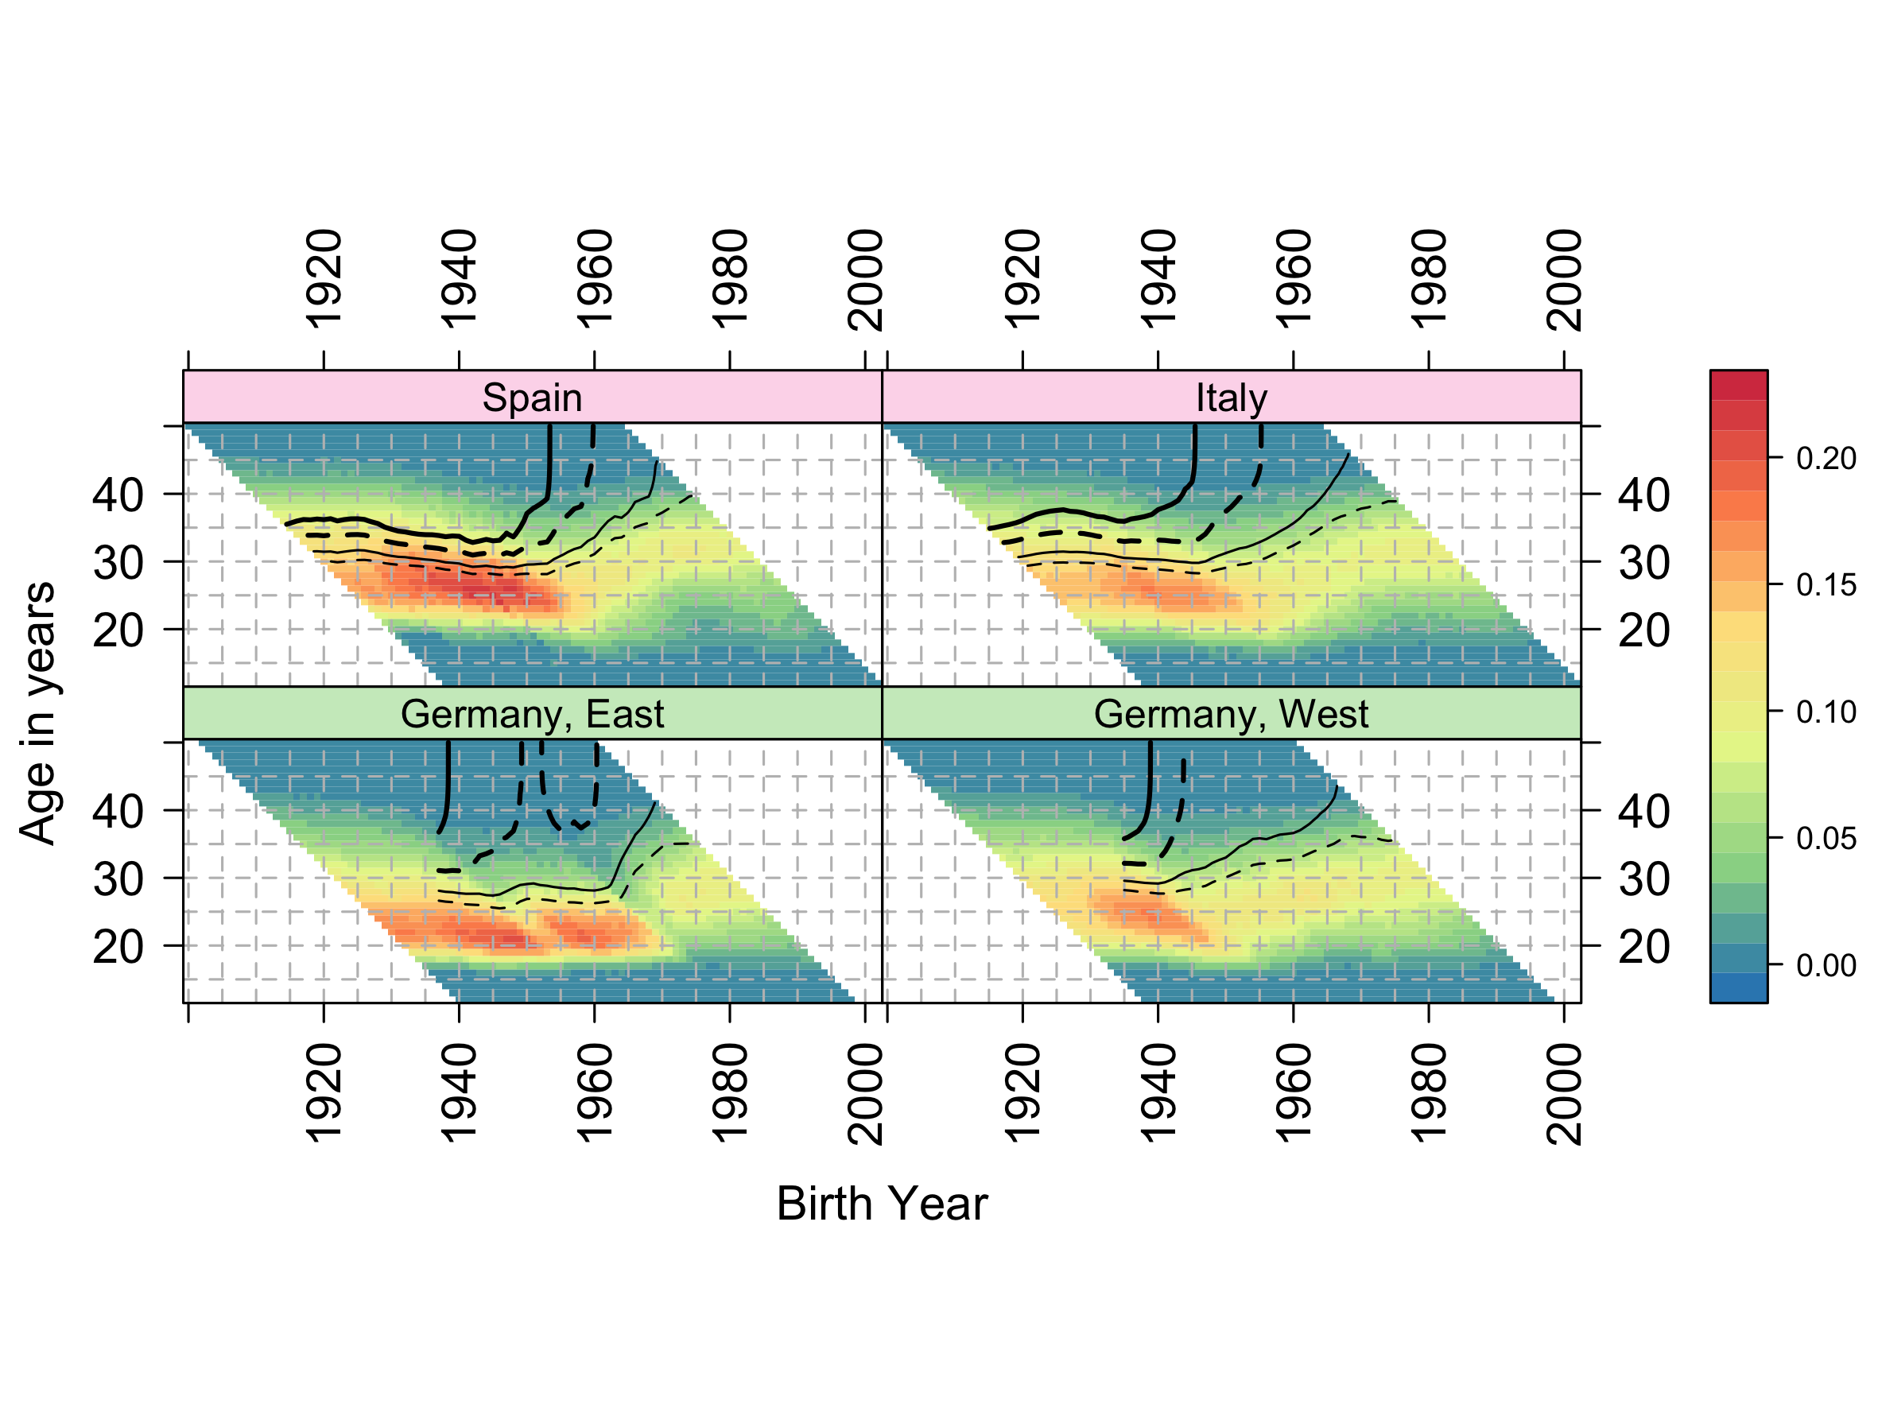

Notes: Shaded bar on the right indicates age-specific fertility rates (ASFRs); thick solid contour line indicates cumulative cohort fertility rate (CCFR)=2.05 (replacement fertility); thick dashed contour line indicates CCFR=1.80; thin solid contour line indicates CCFR=1.50; thin dashed contour line indicates CCFR=1.30.

Source: Human Fertility Database (HFD) and Human Fertility Collection (HFC), own calculations.

## Norway and non-European English-speaking countries

Figure 2 compares fertility trends of Norway with two pairs of English-speaking countries - New Zealand and Australia; and the USA and Canada. Each of these countries have relatively high fertility for affluent world nations. Compared with Australia, New Zealand has somewhat higher fertility with total cohort fertility levels (thick solid contour) being achieved by age 40 years in the 1975 cohort, and with this contour appearing to level off at around this age; this is in contrast to Australia, where replacement levels were last met for the 1966 cohort.

Norway and the USA, though different in many ways, are similar in their fertility trends, in that they are the only populations within the dataset where replacement fertility (RF) levels by cohort were ‘recovered’ by latter cohorts after being ‘lost’ by earlier cohorts; this can be seen by noting the parallel pairs of thick black vertical contour lines in both countries. In Norway, replacement fertility was first ‘lost’ after around the 1953 cohort then ‘recovered’ after the 1956 cohort; and in the USA RF was ‘lost’ by the 1950 cohort then ‘recovered’ after the 1964 cohort. Within Norway RF levels look set to disappear with latter cohorts, as the RF line hovers around age 43 in the latest period, whereas in the USA it appears to have stabilised around age 36. Of these populations, Canada has the lowest fertility, and appears to have stabilised at levels between 1.50 and 1.80 children per woman.

Looking at the colour and shading of cells, the USA is distinct amongst affluent world nations in having a wider range of ages of high fertility, with less evidence of fertility postponement within the population overall than in most other comparable nations.

Figure Composite Fertility Lattice Plots for Norway and non-European English-speaking countries

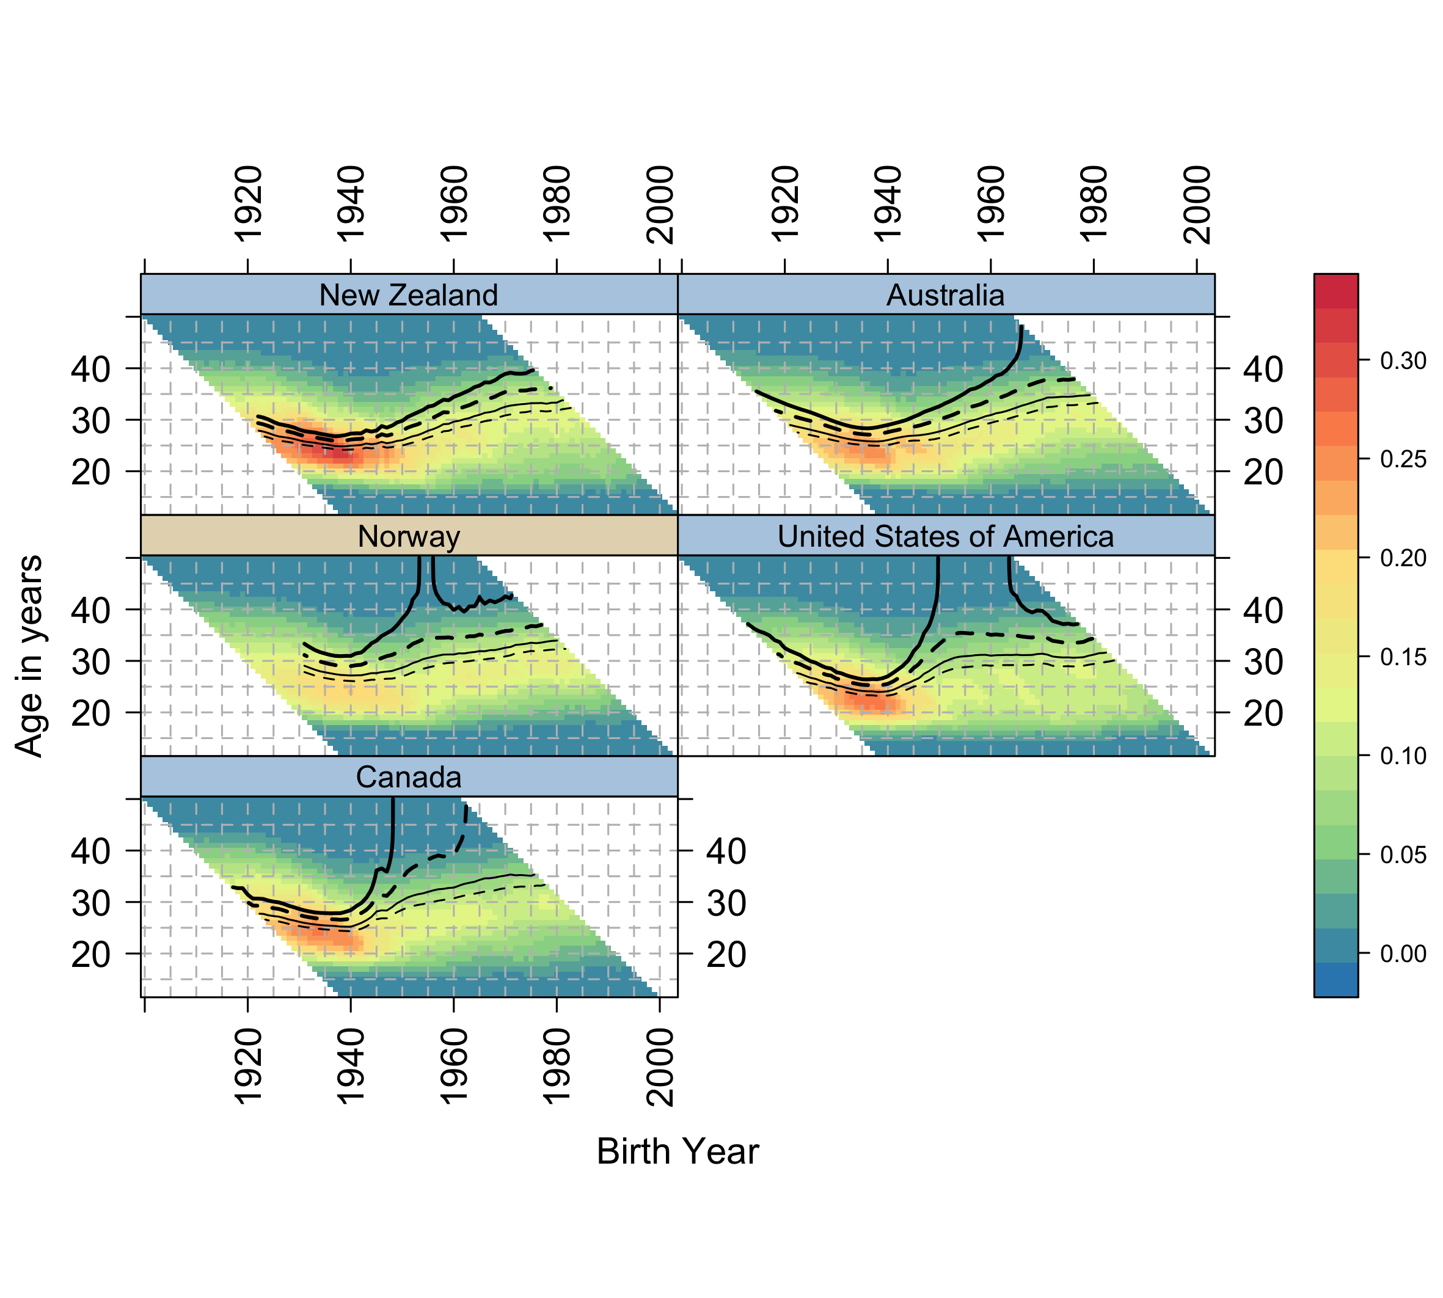

Notes: Shaded bar on the right indicates age-specific fertility rates (ASFRs); thick solid contour line indicates cumulative cohort fertility rate (CCFR)=2.05 (replacement fertility); thick dashed contour line indicates CCFR=1.80; thin solid contour line indicates CCFR=1.50; thin dashed contour line indicates CCFR=1.30.

Source: Human Fertility Database (HFD) and Human Fertility Collection (HFC), own calculations.

## Ireland and Great Britain

As Figure 3 indicates, the British Isles comprise populations with very different fertility trends. Both the Republic of Ireland (RoI) and Northern Ireland are relatively small populations, with fairly high fertility. RoI appears likely to stabilise above RF, and Northern Ireland to either do so as well or only fall slightly below RF. England & Wales – treated as one population – lost RF after the 1951 birth cohort, but appear to have stabilised slightly above 1.80 children per woman. Scotland lost RF by the same birth cohort, but then also lost fertility levels of 1.80 children per woman after the 1960 birth cohort.

Figure Composite Fertility Lattice Plots for Ireland, Northern Ireland, England and Wales, and Scotland

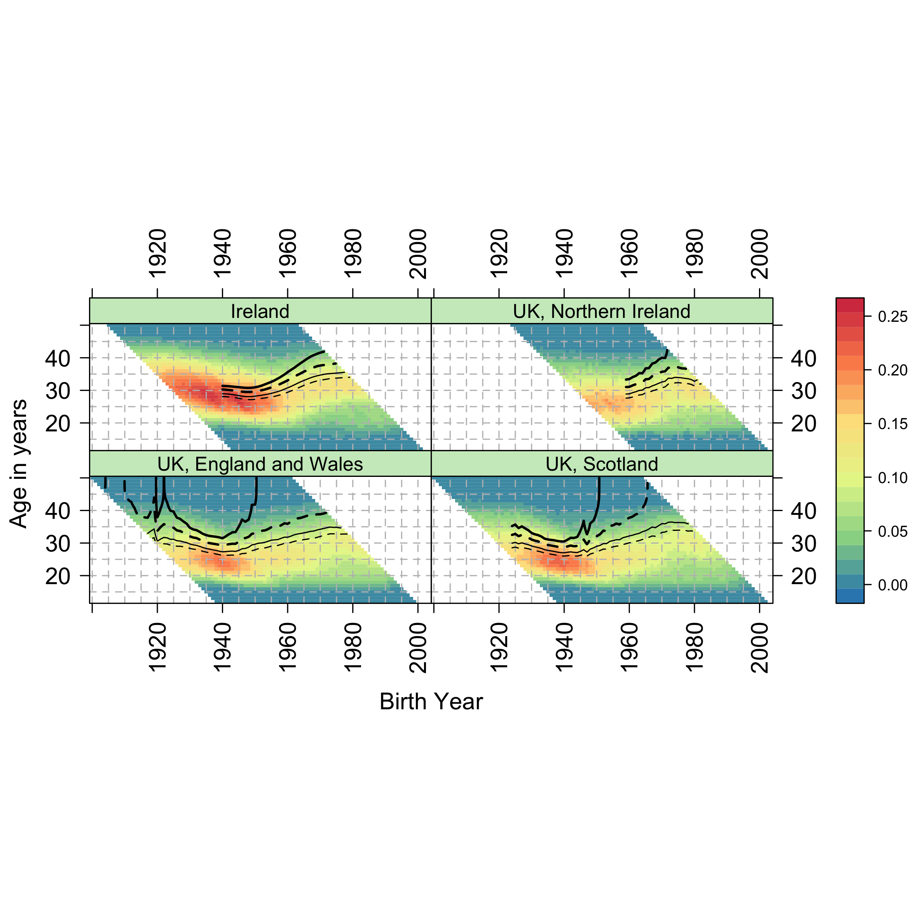

Notes: Shaded bar on the right indicates age-specific fertility rates (ASFRs); thick solid contour line indicates cumulative cohort fertility rate (CCFR)=2.05 (replacement fertility); thick dashed contour line indicates CCFR=1.80; thin solid contour line indicates CCFR=1.50; thin dashed contour line indicates CCFR=1.30.

Source: Human Fertility Database (HFD) and Human Fertility Collection (HFC), own calculations.

## East and South Asian Countries

Figure 4 compares Taiwan, Japan and the Republic of Korea. All countries industrialised very rapidly, leading to very different experiences by cohort. This is reflected in very rapid changes in both total fertility by cohort, and the ages of peak fertility. Japan is characterised by long-standing low fertility, and fertility levels by cohort were very close to 2.05 for cohorts born between around 1933 and 1944, with some cohorts reaching this level but not others of very similar birth year; this variability between cohorts as to whether RF levels were met results in a series of vertical lines after around the age of 43 for these cohorts. After the 1944 cohort, fertility then fell briefly below 1.80 for around the 1945 cohort, then again after the 1960 cohort; cohorts born around 1970 look unlikely to meet 1.50, and the age at which the latter cohorts are reaching 1.30 children per woman is now approaching 40 years, so fertility may decline yet further.

Taiwan perhaps saw the fastest decline of the three populations in fertility, moving from a higher fertility for cohorts born up to around 1955, to very low fertility for cohorts born after around 1970. Of the three populations, the Republic of Korea appears more likely to sustain fertility levels of between 1.50 and 1.80 children per woman, and so fall less far behind RF levels than the other countries.

Figure Composite Fertility Lattice Plots for Taiwan, Republic of Korea, and Japan

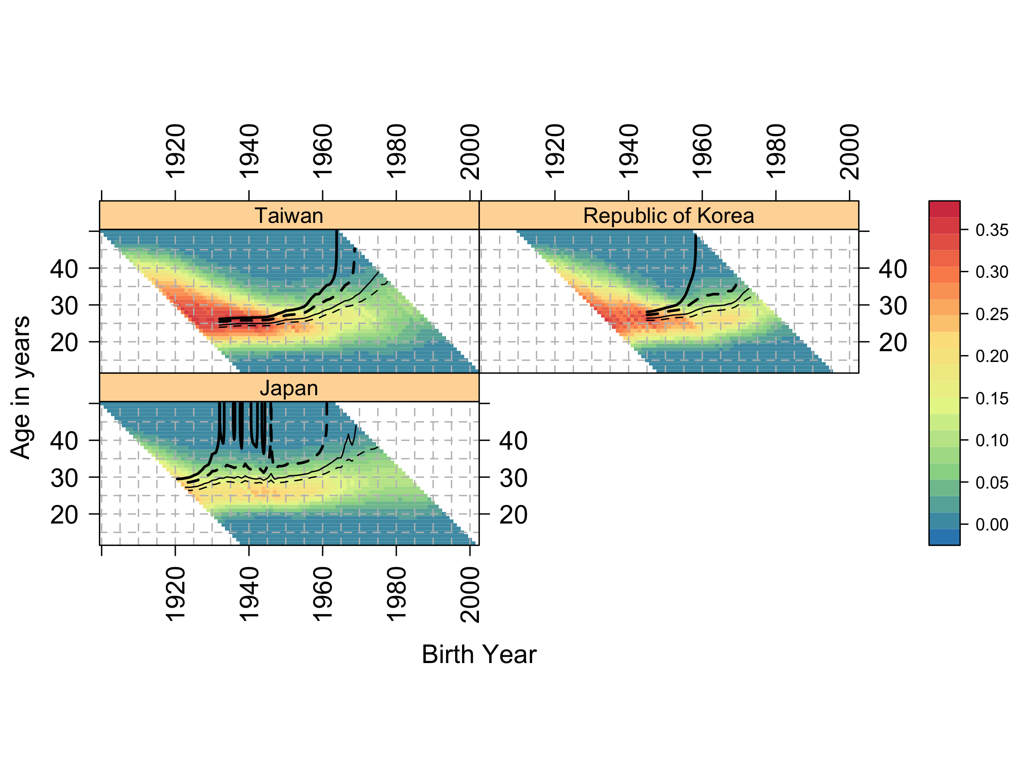

Notes: Shaded bar on the right indicates age-specific fertility rates (ASFRs); thick solid contour line indicates cumulative cohort fertility rate (CCFR)=2.05 (replacement fertility); thick dashed contour line indicates CCFR=1.80; thin solid contour line indicates CCFR=1.50; thin dashed contour line indicates CCFR=1.30.

Source: Human Fertility Database (HFD) and Human Fertility Collection (HFC), own calculations.

## All countries

Figure 5 shows the composite fertility lattice plots for 45 countries, and so represents a visual summary of hundreds of thousands of separate ASFRs. Because of the number of populations being compared, HFC/HFD population codes are used and no gridlines are added to avoid overplotting. A separate version of the figure is available at a higher resolution, with full country names and gridlines, in the online appendix. A common scale is used to for ASFRs for all countries. As mentioned previously, the colour of the strips which label each country indicates the broad geographic macro-regional grouping of countries, and fertility trends can be further explored by comparing the fertility trends of countries by these groups.

Figure Composite Fertility Lattice Plot for 45 countries

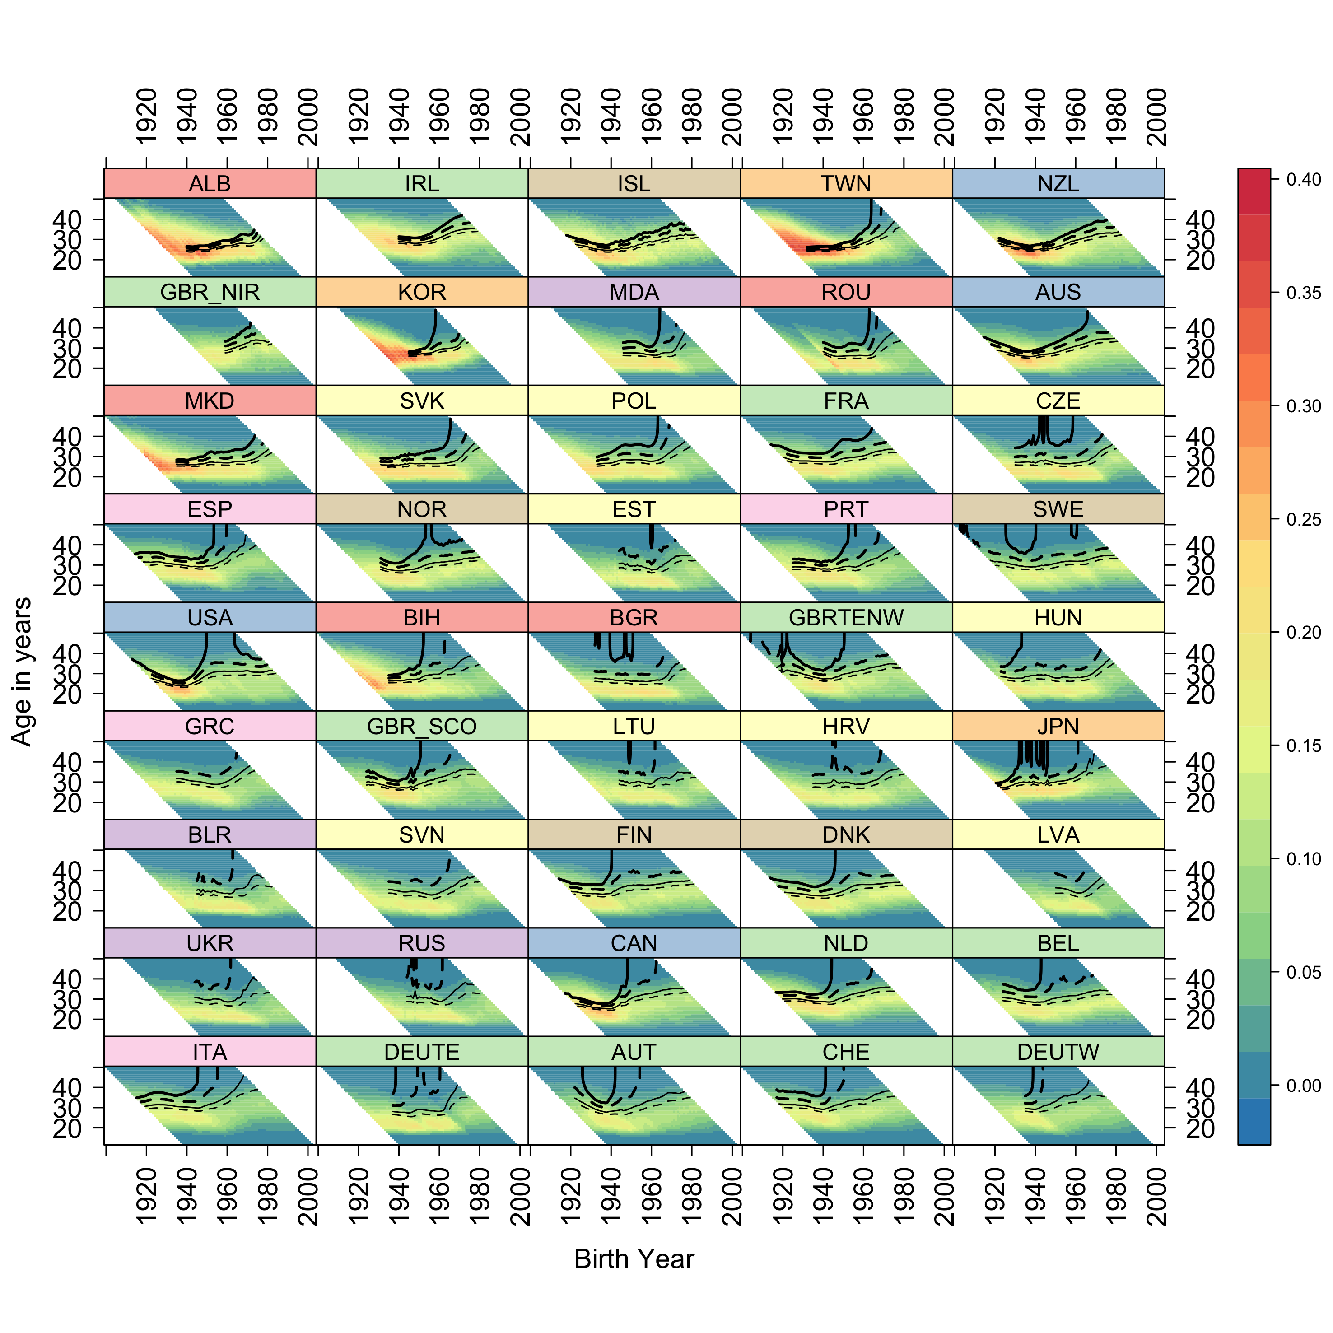

Notes: Shaded bar on the right indicates age-specific fertility rates (ASFRs); thick solid contour line indicates cumulative cohort fertility rate (CCFR)=2.05 (replacement fertility); thick dashed contour line indicates CCFR=1.80; thin solid contour line indicates CCFR=1.50; thin dashed contour line indicates CCFR=1.30.

Source: Human Fertility Database (HFD) and Human Fertility Collection (HFC), own calculations.

# Summary and conclusions

Complex data visualisations through composite fertility lattice plots reveal a considerable degree of heterogeneity in the development of fertility trends over time both within and across geographical macro-regions. Fertility patterns reconstructed by combining data visualisations of age-specific and implied cumulative cohort fertility rates appear to reflect differences in the institutional, socio-economic, political, cultural and normative contexts, suggesting different pathways of transition to low fertility.

Among low fertility countries, we illustrated the cases of Italy and Spain versus East and West Germany. For Germany, it appears that replacement fertility levels were lost for cohorts born in the period preceding World War II, compared to Italy and Spain, where replacement fertility was loss for cohorts born in subsequent periods. In line with other studies (Sobotka *et al.*, 2011; Frejka, 2017), in East and West Germany fertility rates continued to steadily decrease across successive cohorts and they appear to have stabilised at levels between 1.30 and 1.50 children per woman. By contrast, Spain and Italy display signs for future cohorts of not being able even to achieve very low levels of cohort fertility (1.30 children per woman).

Notable exceptions in the HFD/HFC dataset are the cases of Norway and the USA which appear to have ‘lost’ and subsequently ‘recovered’ replacement fertility over time, by moving from earlier to more recent cohorts. This is in line with previous studies (Shkolnikov *et al.*, 2007; Burkimsher, 2017). Recuperation patterns may be due, among other factors, to the influence of immigrant fertility (for the USA, see Choi (2014); Fernández and Fogli (2006, 2009); for Norway, see Østby (2002) and for an alternative view, Tønnessen (2015)). In the case of Norway, sustained replacement fertility levels may also be explained by generous welfare provisions, in terms of childcare and parental leave, and the ideals of gender equality widely spread at the societal level (Kravdal, 2016).

When comparing European English-speaking countries, the Republic of Ireland and Northern Ireland seem to have stabilised around replacement fertility. By contrast, England and Wales appears to sustain fertility levels of around 1.80 children per woman, whereas Scotland displays lower cohort fertility levels. Recent studies suggest that immigration may play a significant role in current UK fertility levels (Kulu, 2005; Tromans, Natamba and Jefferies, 2009; Dubuc, 2012; Robards and Berrington, 2016).

Among Asian countries, Japan features long-standing low fertility patterns, with earlier cohorts showing a high level of variability in high fertility and recent cohorts stabilising at very low fertility levels. Taiwan stands out for having witnessed the fastest transition to low fertility, moving from high to very low cohort fertility in the space of 15 years, whereas the Republic of Korea appears to have stabilised at higher cohort fertility levels. The fertility patterns among Asian countries may reflect different socio-economic, policy and cultural contexts (Straughan, Chan and Jones, 2009; Westley, Choe and Retherford, 2010; Suzuki, 2013; Fukuda, 2016; Gauthier, 2016; Lee and Lin, 2016).

The composite data visualisations which were presented as illustrative cases in this paper provide an initial basis intended to encourage further investigation in the development of different pathways of the transition to low fertility across ages, cohorts and countries. We hope that at-a-glance comparisons of these different analytical dimensions may contribute to help to formulate new research questions and hypotheses on the possible mechanisms underlying different fertility pathways.

# References

Adserà, A. (2011) ‘Where are the babies? Labor market conditions and fertility in Europe’, *European Journal of Population*. Springer, 27(1), pp. 1–32.

Adserà, A. and Ferrer, A. (2014) ‘Immigrants and demography: Marriage, divorce, and fertility’, in Chiswick, B. R. and Miller, P. W. (eds) *Handbook of the economics of international migration*. Oxford: Elsevier, pp. 315–358.

Anderson, T. and Kohler, H.-P. (2015) ‘Low Fertility, Socioeconomic Development, and Gender Equity’, *Population and Development Review*, 41(3), pp. 381–407. doi: 10.1111/j.1728-4457.2015.00065.x.

Andersson, G. (2004) ‘Childbearing after Migration: Fertility Patterns of Foreign-born Women in Sweden’, *International Migration Review*, 38(2), pp. 747–774. doi: 10.1111/j.1747-7379.2004.tb00216.x.

Andersson, G. *et al.* (2009) ‘Cohort Fertility Patterns in the Nordic Countries’, *Demographic Research*, 20(14), pp. 313–352. doi: 10.4054/DemRes.2009.20.14.

Basten, S., Sobotka, T. and Zeman, K. (2014) ‘Future fertility in low fertility countries’, in Lutz, W., Butz, W. P., and KC, S. (eds) *World Population and Human Capital in Twenty-First Century*. Oxford: Oxford University Press, pp. 39–146. doi: 10.1093/acprof.

Billari, F. and Kohler, H.-P. (2004) ‘Patterns of low and lowest-low fertility in Europe’, *Population studies*. Taylor & Francis, 58(2), pp. 161–176.

Blossfeld, H.-P. and Huinink, J. (1991) ‘Human capital investments or norms of role transition? How women’s schooling and career affect the process of family formation’, *American journal of Sociology*. University of Chicago Press, 97(1), pp. 143–168.

Bongaarts, J. and Watkins, S. C. (1996) ‘Social interactions and contemporary fertility transitions’, *Population and Development Review*. JSTOR, 22(4), pp. 639–682.

Burkimsher, M. (2017) ‘Evolution of the shape of the fertility curve: Why might some countries develop a bimodal curve?’, *Demographic Research*, 37(11), pp. 295–324.

Caltabiano, M., Castiglioni, M. and Rosina, A. (2009) ‘Lowest-low fertility: Signs of a recovery in Italy?’, *Demographic Research*, 21(23), pp. 681–718. doi: 10.4054/DemRes.2009.21.23.

Caselli, G. and Vallin, J. (2005) ‘From situation events in time to the Lexis Diagram and the Computing of rates’, in Caselli, G., Vallin, J., and Wunsch, G. (eds) *Demography: Analysis and Synthesis2*. Boston, MA: Academic Press.

Choi, K. H. (2014) ‘Fertility in the context of Mexican migration to the United States: A case for incorporating the pre-migration fertility of immigrants’, *Demographic Research*. Max Planck Institut für Demografische Forschung, 30(24), pp. 703–737.

d’Addio, A. C. and d’Ercole, M. M. (2005) *Trends and determinants of fertility rates: The role of policies. OECD Social, Employment and Migration Working Paper 27*. OECD Socia. OECD Publishing. Available at: http://dx.doi.org/10.1787/880242325663%0A.

Davis, K. (1945) ‘The World Demographic Transition’, *The Annals of the American Academy of Political and Social Science*, 237(Jan.), pp. 1–11. Available at: http://www.jstor.org/stable/1025490.

Dubuc, S. (2012) ‘Immigration to the UK from High-Fertility Countries: Intergenerational Adaptation and Fertility Convergence’, *Population and Development Review*, 38(2), pp. 353–368. doi: 10.1111/j.1728-4457.2012.00496.x.

Esping‐Andersen, G. and Billari, F. C. (2015) ‘Re‐theorizing Family Demographics’, *Population and Development Review*. Wiley Online Library, 41(1), pp. 1–31.

Fernández, R. and Fogli, A. (2006) ‘Fertility: The role of culture and family experience’, *Journal of the European Economic Association*. Wiley Online Library, 4(2‐3), pp. 552–561.

Fernández, R. and Fogli, A. (2009) ‘Culture: An empirical investigation of beliefs, work, and fertility’, *American Economic Journal: Macroeconomics*. American Economic Association, 1(1), pp. 146–177.

Frejka, T. (2017) ‘The Fertility Transition Revisited: A Cohort Perspective’, *Comparative Population Studies*, 42, pp. 89–116. doi: 10.12765/CPoS-2017-10en.

Frejka, T., Jones, G. W. and Sardon, J. (2010) ‘East Asian childbearing patterns and policy developments’, *Population and Development Review*. Wiley Online Library, 36(3), pp. 579–606. Available at: 10.1111/j.1728-4457.2010.00347.x.

Fukuda, N. (2016) *Marriage and Fertility Behaviour in Japan. Economic Status and Value Orientation*. Springer.

Gauthier, A. H. (2016) ‘Governmental Support for families and obstacles to fertility in East Asia and other industrialized regions’, in Rindfuss, R. R. and Choe, M. K. (eds) *Low Fertility, Institutions, and their Policies*. Springer, pp. 283–303.

Goldscheider, F., Bernhardt, E. and Lappegård, T. (2015) ‘The gender revolution: A framework for understanding changing family and demographic behavior’, *Population and Development Review*. Wiley Online Library, 41(2), pp. 207–239. Available at: 10.1111/j.1728-4457.2015.00045.x.

Goldstein, J. R., Sobotka, T. and Jasilioniene, A. (2009) ‘The End of “Lowest-Low” Fertility?’, *Population and Development Review*, 35(4), pp. 663–699.

Grigorieva, O. *et al.* (2015) *Methods Protocol for the Human Fertility Collectoin*, *www.fertilitydata.org*. Available at: http://www.fertilitydata.org/docs/methods.pdf (Accessed: 25 August 2017).

Kohler, H.-P. (2001) *Fertility and social interaction: An economic perspective*. Oxford: Oxford University Press.

Kravdal, Ø. (2016) ‘Not so Low Fertility in Norway—A Result of Affluence, Liberal Values, Gender-Equality Ideals, and the Welfare State’, in Rindfuss, R. R. and Choe, M. K. (eds) *Low Fertility, Institutions, and their Policies*. Springer, pp. 13–47.

Kulu, H. (2005) ‘Migration and fertility: Competing hypotheses re-examined’, *European Journal of Population*, 21(1), pp. 51–87. doi: 10.1007/s10680-005-3581-8.

Lee, M. and Lin, Y.-H. (2016) ‘Transition from Anti-natalist to Pro-natalist Policies in Taiwan’, in Rindfuss, R. R. and Choe, M. K. (eds) *Low Fertility, Institutions, and their Policies*. Springer, pp. 259–281.

Lesthaeghe, R. (1995) ‘The second demographic transition in Western countries: An interpretation’, in Oppenheim Mason, K. and Jensen, A.-M. (eds) *Gender and family change in industrialized countries*. Oxford: Clarendon Press, pp. 17–62.

Lesthaeghe, R. (2010) ‘The unfolding story of the Second Demographic Transition’, *Population and Development Review*, 36(2), pp. 211–251. doi: 10.1111/j.1728-4457.2010.00328.x.

Lesthaeghe, R. and van de Kaa, D. (1986) ‘Twee demografische transities?’, in Lesthaeghe, R. and van de Kaa, D. (eds) *Bevolking: Groei en krimp. Mens an Maatschappij*. Deventer: Van Loghum-Slaterus, pp. 9–24.

Lesthaeghe, R. and Surkyn, J. (1988) ‘Cultural dynamics and economic theories of fertility change’, *Population and Development Review*. JSTOR, 14(1), pp. 1–45.

Lutz, W., Butz, W. P. and KC, S. (2014) *World Population and Human Capital in the Twenty-First Century*. Edited by W. Lutz, W. P. Butz, and S. KC. Oxford: Oxford University Press. doi: 10.1093/acprof.

Lutz, W. and Skirbekk, V. (2005) ‘Policies Addressing the Tempo Effect in Low-Fertility Countries’, *Population and Development Review*, 31(4), pp. 699–720.

Max Planck Institute for Demographic Research (Germany) and Vienna Institute of Demography (Austria) (2015) *Human Fertility Collection*. Available at: http://www.fertilitydata.org/cgi-bin/terms.php (Accessed: 19 November 2016).

Max Planck Institute for Demographic Research (Germany) and Vienna Institute of Demography (Austria) (2016) *Human Fertility Database*. Available at: www.humanfertility.org (Accessed: 1 January 2015).

McDonald, P. (2002) ‘Sustaining fertility through public policy: The range of options’, *Population*. INED, 57(3), pp. 417–446.

McDonald, P. (2006) ‘Low fertility and the state: The efficacy of policy’, *Population and Development Review*. Wiley Online Library, 32(3), pp. 485–510.

Mills, M. and Blossfeld, H.-P. (2005) ‘Globalization, uncertainty and the early life course’, in Blossfeld, H.-P. et al. (eds) *Globalization, uncertainty and youth in society*. London: Routledge, pp. 1–23.

Montgomery, M. R. and Casterline, J. B. (1996) ‘Social Influence, Social Learning, and New Models of Fertlity’, *Population and Development Review*, 22, pp. 151–175.

Myrskylä, M., Goldstein, J. R. and Cheng, Y. A. (2013) ‘Forecasts for the Developed World : Rises ’, 39(1), pp. 31–56.

Neuwirth, E. (2014) ‘RColorBrewer: ColorBrewer Palettes’.

Notestein, F. W. (1945) ‘Population: the long view’, in Schultz, T. (ed.) *Food for the World*. Chicago: Chicago University Press, pp. 36–57.

Notestein, F. W. (1953) ‘Economic problems of population change’, in *Proceedings of the Eighth International Conference of Agricultural Economists*. New York, pp. 13–31.

Oeppen, J. and Vaupel, J. W. (2002) ‘Broken limits to life expectancy’, *Science*, 296(10 May), pp. 1029–1031.

Oppenheimer, V. K. (1994) ‘Women’s rising employment and the future of the family in industrial societies’, *Population and development review*. JSTOR, 20(2), pp. 293–342.

Østby, L. (2002) *The demographic characteristics of immigrant population in Norway. Report No. 22.* Oslo: Statistics Norway.

Rindfuss, R. R. and Choe, M. K. (2015) *Low and Lower Fertility: Variations Across Developed Countries*. Edited by R. R. Rindfuss and M. K. Choe. Springer.

Robards, J. and Berrington, A. (2016) ‘The fertility of recent migrants to England and Wales’, *Demographic Research*, 34(36), pp. 1037–1052.

Sánchez-Barricarte, J. J. (2017) ‘Mortality–fertility synergies during the demographic transition in the developed world’, *Population Studies*. Taylor & Francis, 71(2), pp. 155–170. doi: 10.1080/00324728.2017.1294701.

Sarkar, D. (2008) *Lattice: Multivariate Data Visualization with R*. New York: Springer.

Schöley, J. and Willekens, F. (2017) ‘Visualizing compositional data on the Lexis surface’, *Demographic Research*, 36(21), pp. 627–658. Available at: 10.4054/DemRes.2017.36.21.

Shkolnikov, V. M. *et al.* (2007) ‘The concentration of reproduction in cohorts of women in Europe and the United States’, *Population and Development Review*. Wiley Online Library, 33(1), pp. 67–100.

Shkolnikov, V. M. *et al.* (2011) ‘Steep increase in best-practice cohort life expectancy’, *Population and Development Review*, 37(3), pp. 419–434. doi: 10.1111/j.1728-4457.2011.00428.x.

Skirbekk, V. (2008) ‘Fertility trends by social status’, *Demographic Research*, 18(5), pp. 145–180.

Sobotka, T. (2008) ‘Overview chapter 7: The rising importance of migrants for childbearing in Europe’, *Demographic Research*, 19(9), pp. 225–248. doi: 10.4054/DemRes.2008.19.9.

Sobotka, T. *et al.* (2011) ‘Postponement and Recuperation in Cohort Fertility: Austria, Germany and Switzerland in a European Context’, *Comparative Population Studies*, 36(2–3), pp. 417–452. doi: 10.4232/10.CPoS-2011-16en.

Straughan, P., Chan, A. and Jones, G. (2009) *Ultra-low fertility in Pacific Asia: trends, causes and policy issues*. Edited by P. Straughan, A. Chan, and G. Jones. Routledge.

Sundström, M. and Stafford, F. P. (1992) ‘Female labour force participation, fertility and public policy in Sweden’, *European Journal of Population*. Springer, 8(3), pp. 199–215.

Suzuki, T. (2013) *Low fertility and population aging in Japan and Eastern Asia*, *Low Fertility and Population Aging in Japan and Eastern Asia*. Springer.

Thévenon, O. (2011) ‘Family policies in OECD countries: A comparative analysis’, *Population and Development Review*. Wiley Online Library, 37(1), pp. 57–87.

Tønnessen, M. (2015) *Why Immigrant Fertility in Norway Has Declined*, *Paper presented at Population Association of America Annual Meeting, San Diego CA, 30 April-2 May*. Wiley Online Library.

Tromans, N., Natamba, E. and Jefferies, J. (2009) ‘Have women born outside the UK driven the rise in UK births since 2001?’, *Population Trends*. Springer, 136(1), pp. 28–42.

Vaupel, J. W., Gambill, B. A. and Yashin, A. I. (1987) *Thousands of Data at a Glance: Shaded Contour Maps of Demographic Surfaces*. Laxenburg, Austria.

Westley, S. B., Choe, M. K. and Retherford, R. D. (2010) ‘Very low fertility in Asia: Is there a problem? Can it be solved?’, *AsiaPacific Issues*. Honolulu, HI: East-West Center, (94).